**Depot Access**

***Work-flow to Use Driver Walk***

The Depot Access preference is accessed through **Load Template** and only one instance of it is permitted.

***Preference Overview***

This preference sets minimal depot access times for pull in/pull out, both for the start/end of the day and mid day.

***Templates Available from Optibus***

***Depot Access***

**Purpose:**

As stated in the Overview **Prerequisites:** None. **Opening Dialog:**

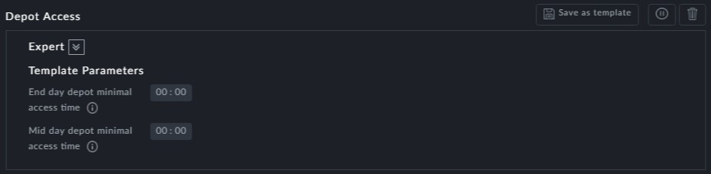

**Points to note:**

**End day depot minimal access time** refers to both start pull out and end pull in



**Mid day depot minimal access time** refers to a mid day pull in and pull out

